

MA478 – Generalized Linear Models
Homework Assignment #3 Requirements

Overview
In this homework assignment, you will explore, analyze, and model a data set containing information on approximately 12,000 commercially available wines. The variables are mostly related to the chemical properties of the wine being sold. The response variable is the number of sample cases of wine that were purchased by wine distribution companies after sampling a wine. These cases would be used to provide tasting samples to restaurants and wine stores around the United States. The more sample cases purchased, the more likely is a wine to be sold at a high-end restaurant. A large wine manufacturer is studying the data to predict the number of wine cases ordered based upon the wine characteristics. If the wine manufacturer can predict the number of cases, then that manufacturer will be able to adjust their wine offering to maximize sales (and, thus, maximize profit).

Your objective is to build a count regression model to predict the number of cases of wine that will be sold given certain properties of the wine. HINT: Sometimes, the fact that a variable is missing is actually predictive of the target. You can only use the variables given to you (or variables that you derive from the variables provided). Below is a short description of the variables of interest in the data set:

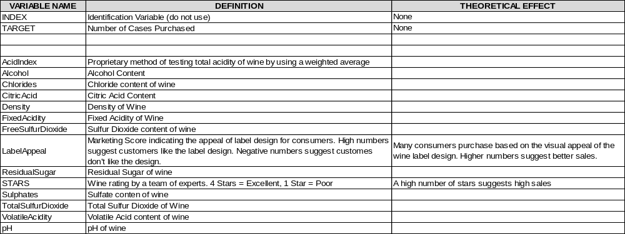

Deliverables:
- A professionally written report submitted in class on Lesson 16. Your write-up should have four sections. Each one is described below. You may assume you are addressing me as an applied statistics and data science savvy Army officer, so please do not need to shy away from technical details.

- Assigned predictions (number of cases of wine sold) for the evaluation data set in an Appendix.

- Include your R statistical programming code in an Appendix (after the predictions).

- Note for this assignment you MUST use generative AI for one of the sections and cannot use it for the other sections. Clearly annotate what section you used it for and provide an appendix of what prompts you used/how you used it.

Write Up:

- DATA EXPLORATION (25 Points)

Provide a short introduction with a clearly stated research question(s) for the assignment. Describe the size and the variables in the wine training data set. Consider that too much detail will cause a manager to lose interest while too little detail will make the manager consider that you aren’t doing your job. Some suggestions are given below. Please do NOT treat this as a check list of things to do to complete the assignment. You should have your own thoughts on what to tell the boss. These are just ideas.
  - Mean / Standard Deviation / Median / Other Summary Statistics
  - Bar Chart or Box Plot of the Data / Other Data Visualizations
  - Is the data correlated to the target variable (or to other variables?)
  - Are any of the variables missing and need to be imputed “fixed”?

- DATA PREPARATION (25 Points)

Describe how you have transformed the data by changing the original variables or creating new variables. If you did transform the data or create new variables, discuss why you did this. HINT: for missing values associated with STARS, you may want to impute with 0 (not rated). Here are some possible transformations.
  - Fix missing values (maybe with a Mean or Median value or other imputation techniques)
  - Create flags to suggest if a variable was missing
  - Transform data by putting it into buckets
  - Mathematical transforms such as log or square root (or use Box-Cox)
  - Combine variables (such as ratios or adding or multiplying) to create new variables

- BUILD MODELS (25 Points)

Using the training data set, build at least two different Poisson regression models, at least two different Negative Binomial regression models, and at least two multiple linear regression models, using different variables (or the same variables with different transformations). Sometimes Poisson and Negative Binomial regression models give the same results. If that is the case, comment on that (and discuss overdispersion). Consider changing the input variables if that occurs so that you get different models. Depending on how you impute missing values, you may want to build zero-inflated Poisson and Negative Binomial count regression models. Describe the technique(s) you used for variable selection. If you manually selected a variable for inclusion into the model or exclusion into the model, indicate why this was done. Discuss the coefficients in the models, do they make sense? In this case, about the only thing you can comment on is the number of stars and the wine label appeal. However, you might comment on the coefficient and magnitude of variables and how they are similar or different from model to model. For example, you might say “pH seems to have a major positive impact in my Poisson regression model, but a negative effect in my multiple linear regression model”. Are you keeping the model even though it is counter intuitive? Why? The boss needs to know.

- SELECT MODELS (25 Points)

Decide on the model performance criteria you are using for selecting the best count regression model. Will you select models with slightly worse performance if it makes more sense or is more parsimonious? Discuss why you selected your models. Provide a comparison table of the performance metrics for all the models. For the count regression model, will you use a metric such as AIC, average squared error, etc.? Be sure to explain how you can make statistical inferences from the model, and discuss other relevant generalized linear model output. If you like the multiple linear regression model the best, please say why. However, you must select a count regression model for model deployment. Using the training data set, determine performance of the count regression model using appropriate GLM metrics. Make predictions using the evaluation data set.

